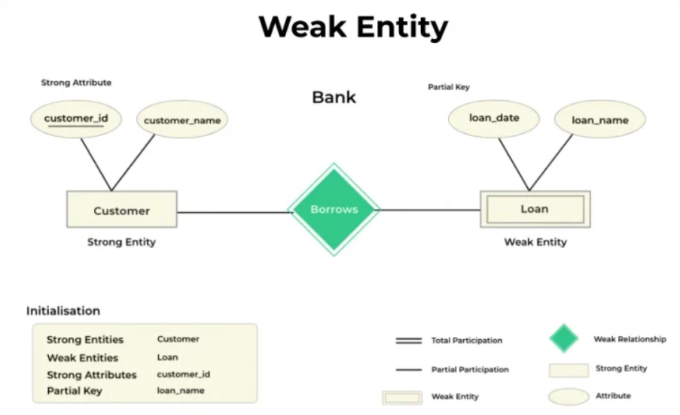

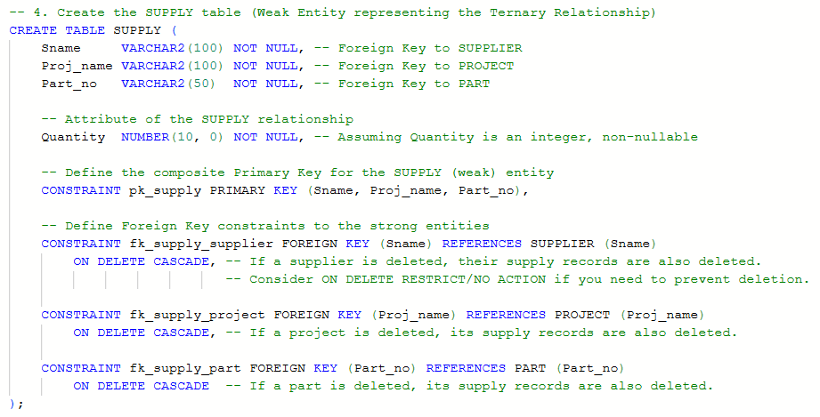

**Separate Tables Approach (More common):**

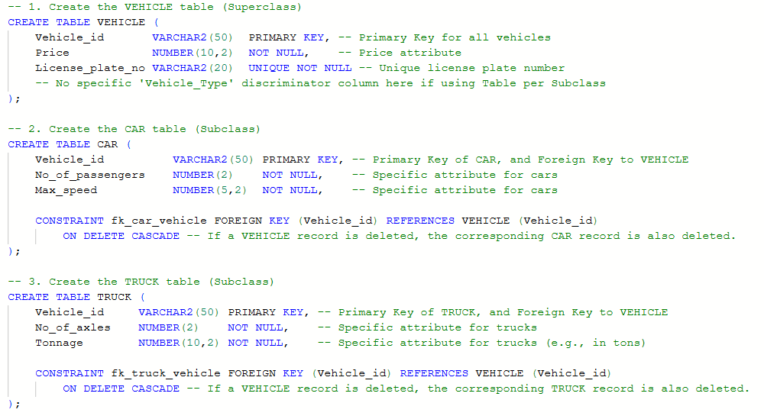

**Disjointness:** The disjoint constraint is not enforced in the separate table approach. This is typically done using **either** a trigger on the VEHICLE table **or** a combination of triggers on the CAR and TRUCK tables, or through application logic.

**Totality:** SQL DDL doesn't inherently enforce that "every row in VEHICLE must have a corresponding row in *either* CAR *or* TRUCK". This requires a check across multiple tables, which is beyond standard CHECK constraints (as they operate only on the current row of the table). Triggers are often used here as well.

To rigorously enforce both **disjoint constraint** and **total completeness** with the "Table per Subclass with Superclass Table" strategy, you typically need to add a **discriminator column** to the **superclass table (VEHICLE)** and use **CHECK constraints** or **triggers**.

**1. A single trigger on Super Class to enforce disjoint constraint (Separate Discriminator columns are required)**

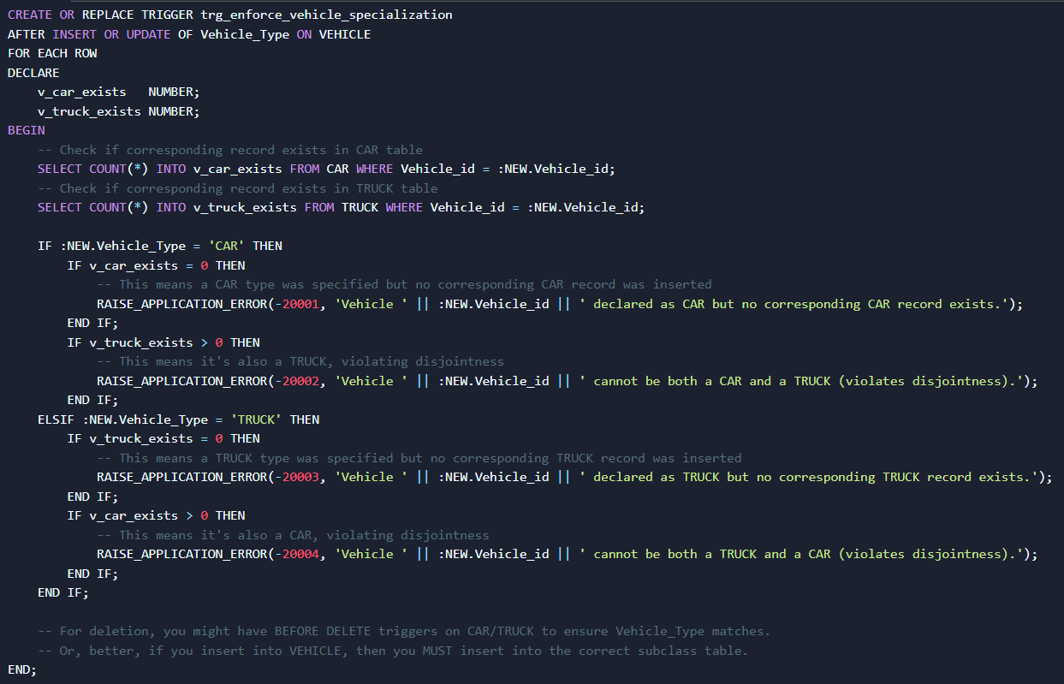

**2. Combination of triggers on Sub Classes to enforce disjoint constraint (Most Common)**

**Single Table Approach (Less common):**

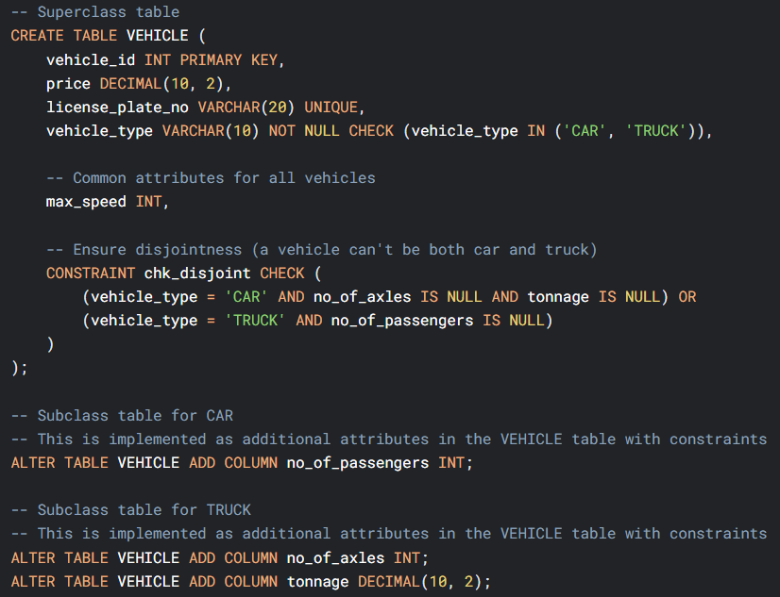

**Composite Attribute**

When converting a **composite attribute** from ERD to SQL, its components always become separate columns in the table. Meaning, we don’t represent composite columns in SQL.

**Multivalued Attribute**

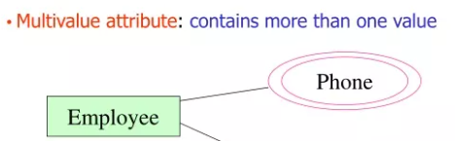

When converting a multivalued attribute in an ERD to SQL, you *must* create a **separate table** for that multivalued attribute.

**Multiple Inheritance**

A subclass can be subclass of more than one superclass (called multiple inheritance).

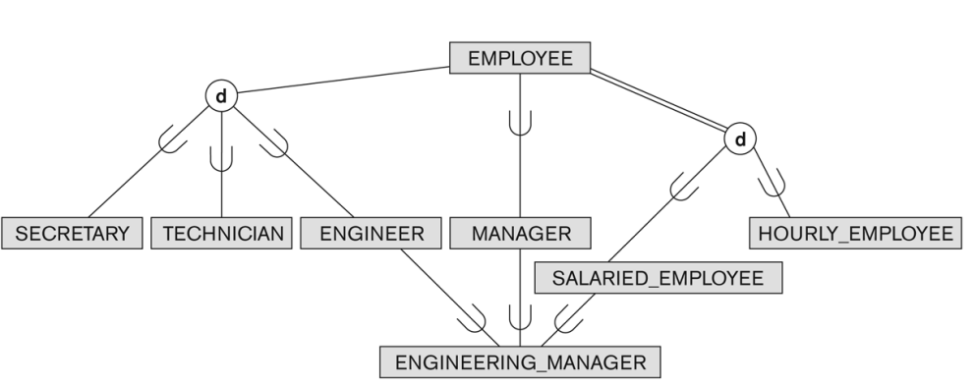

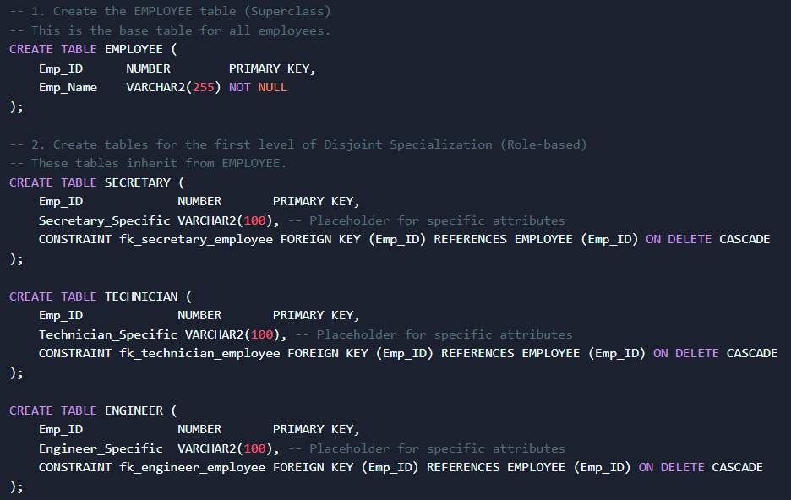

**Categorization (Union)**

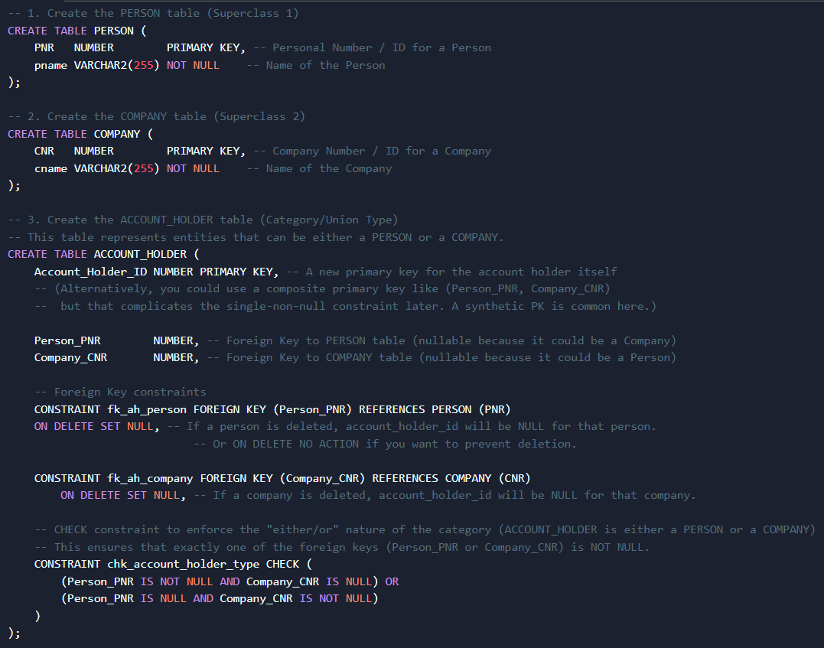

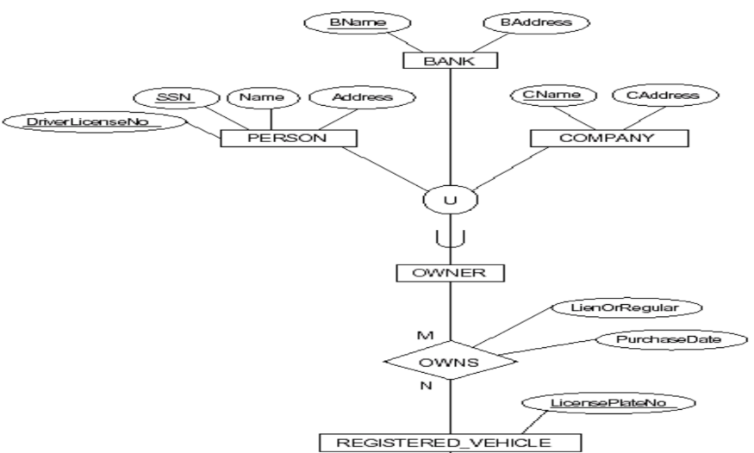

Multiple entities (PERSON, BANK, COMPANY) own different vehicles, so a showroom wants to compile all of them into one OWNER entity class.

